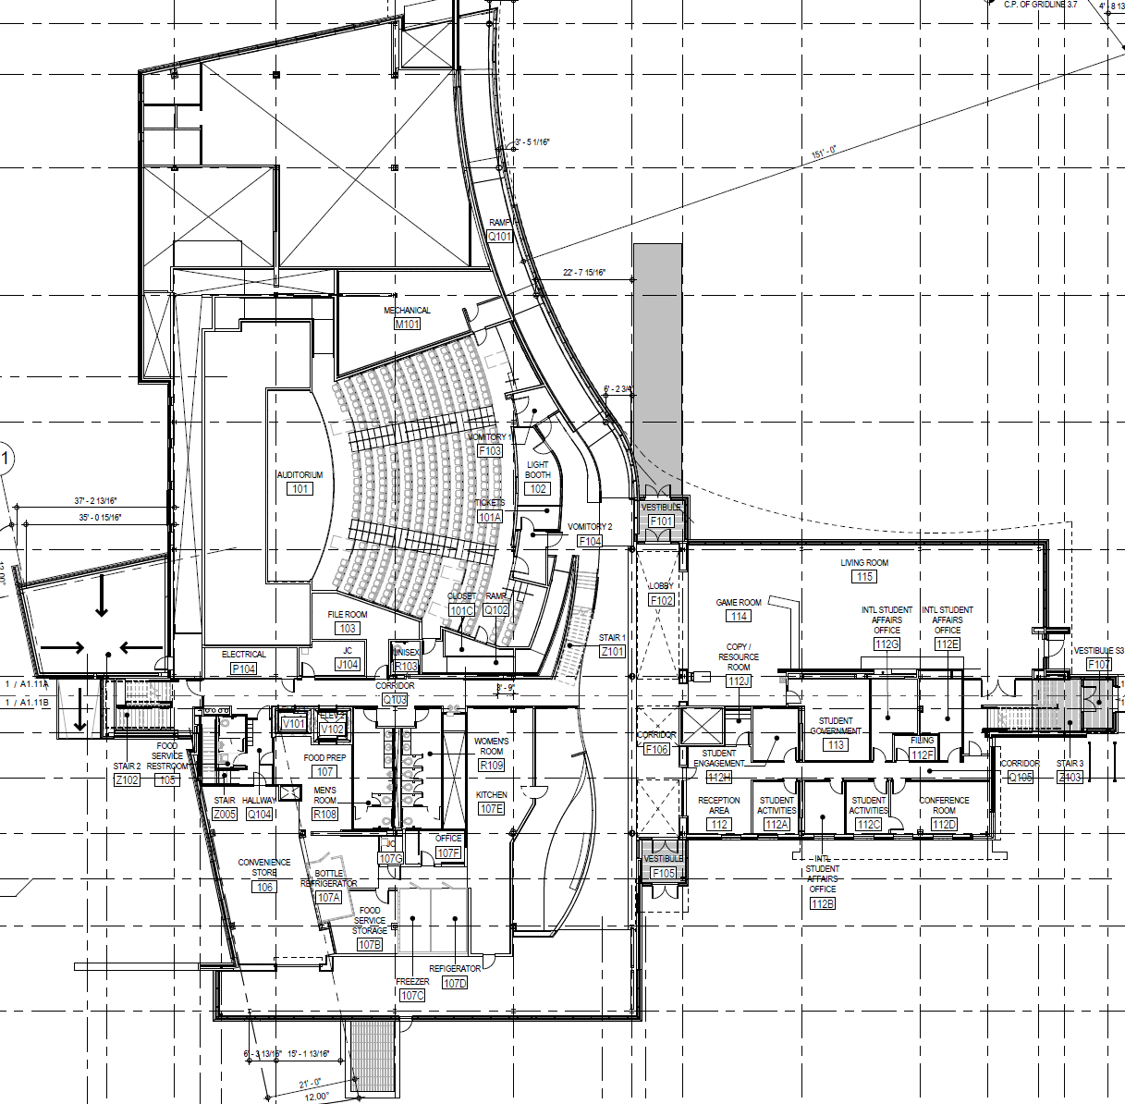

**SEC MAIN LEVEL**